**THE TABLEAU HR SCORECARD ; MEASURING SUCCESS IN TALENT MANAGEMNT**

**INTODUCTION :**

* 1. **Overview :**

**Human resources (HR) management professionals say that talent management, defined as the process through which organizations meet their needs for talent in strategic jobs is one of the biggest challenges that organizations will face in the 21st century Analyses indicate that talented employees make up from 3 to 5% of all employees within an organization In view of its current popularity and the relatively large amount of past research one might expect the field to be well defined and supported by a wide range of research and praxis. However, numerous writers and researchers believe that the field currently lacks a clear definition, framework and general objectives (Lewis and a stable theoretical basis 2016) and empirical. Gallardo-Gallardo and (2016) found that the largest amount of empirical research on talent management is conducted in the United States, Great Britain, Australia, Netherlands and Ireland. This has led to a noticeable Anglo-Saxon influence and a focus on researching the process of talent management in the private sector and in multinationals.**

* 1. **Purpose :**

**This paper investigates the effects of different types of talent management strategies on organisational performance. We introduce four different strategies and show how they affect organisational performance. For this purpose, we use a particularly detailed dataset of 138 Swiss companies.**

**PROBLEM DEFINITION OF DESIGN THINKINGS:**

**2.1 Empathy map:**

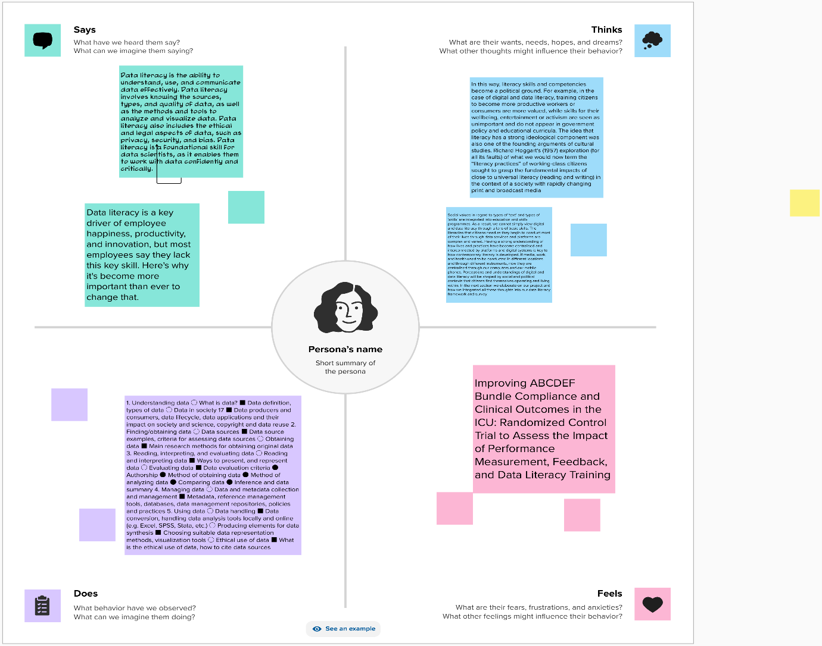

**2.2 Ideation & Brainstorming Map**

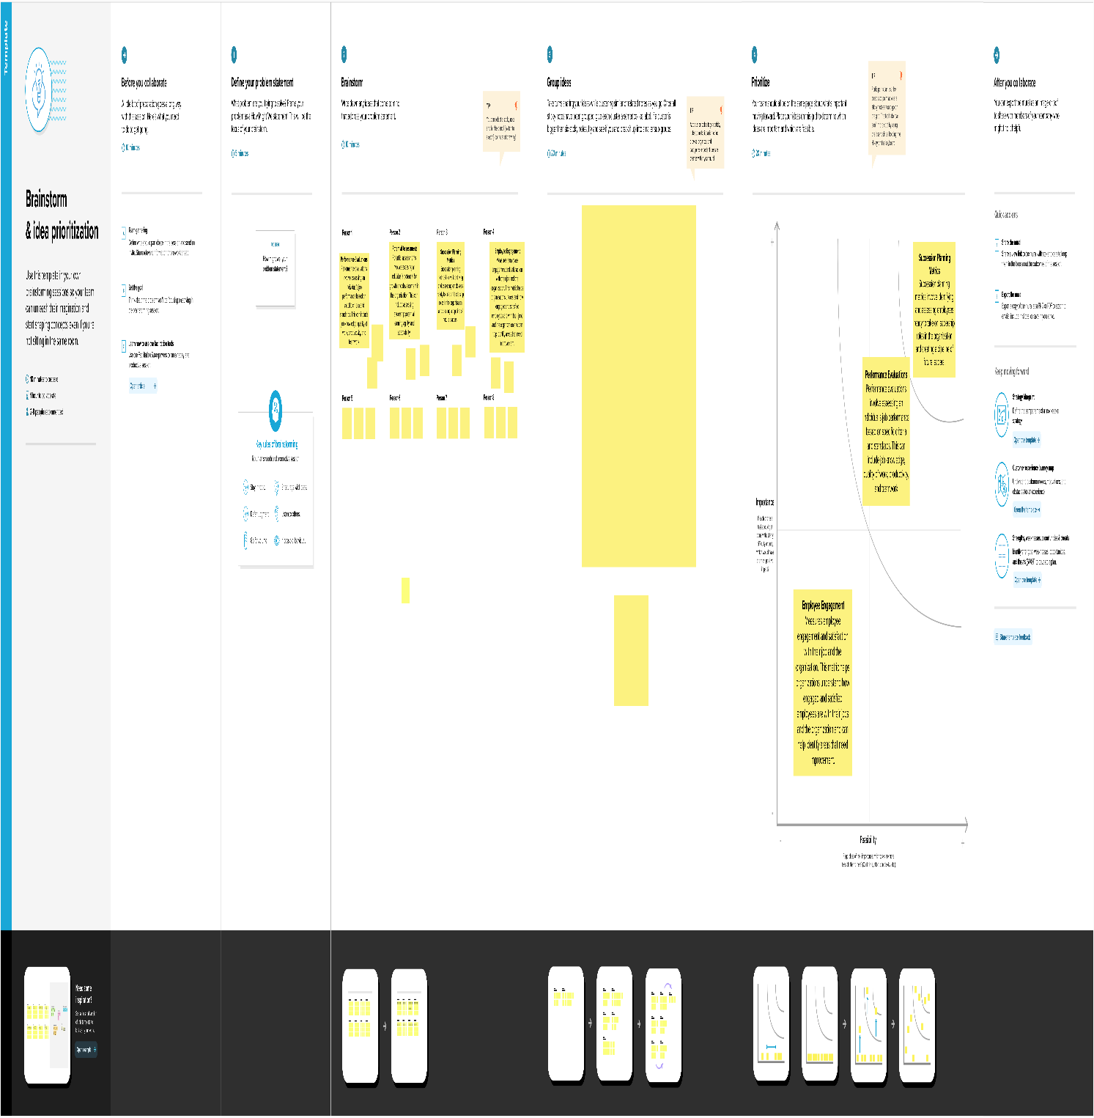**RESULT :**

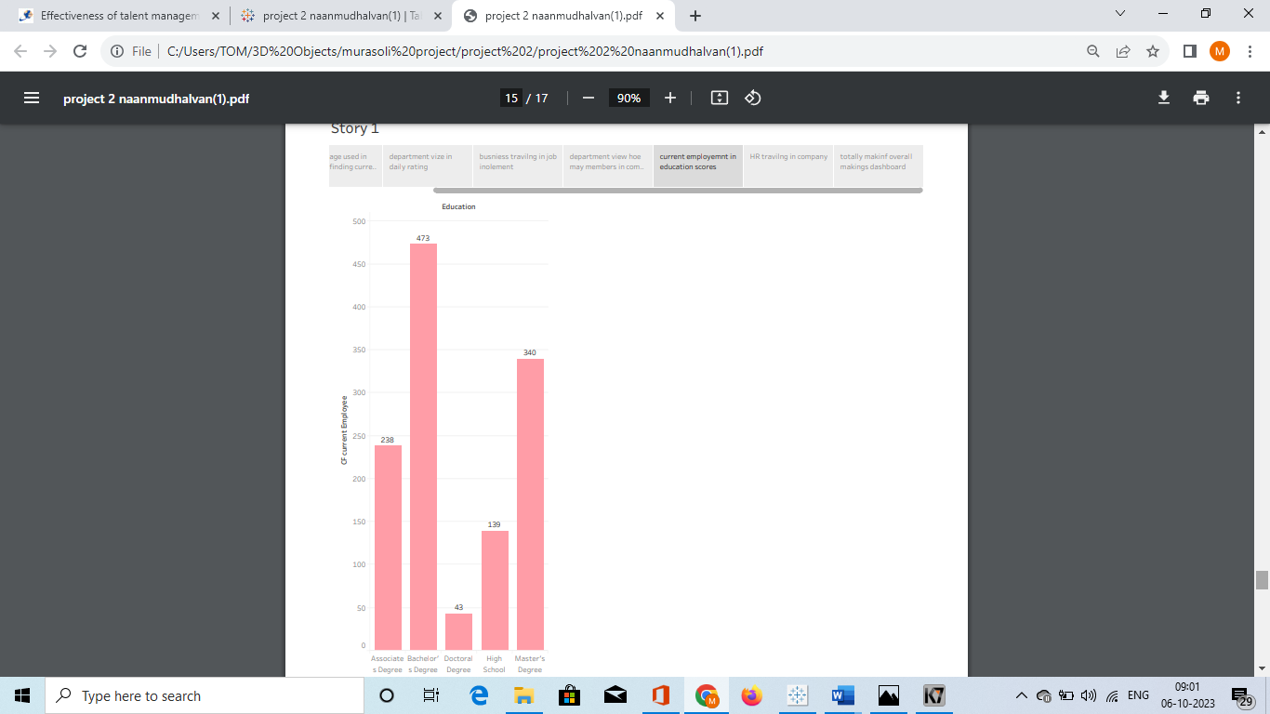

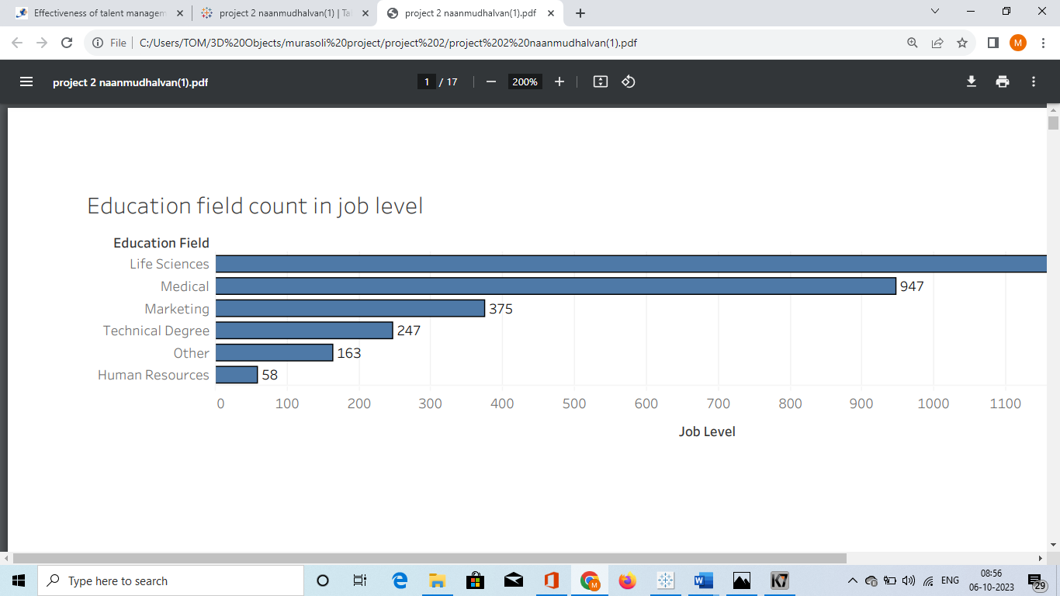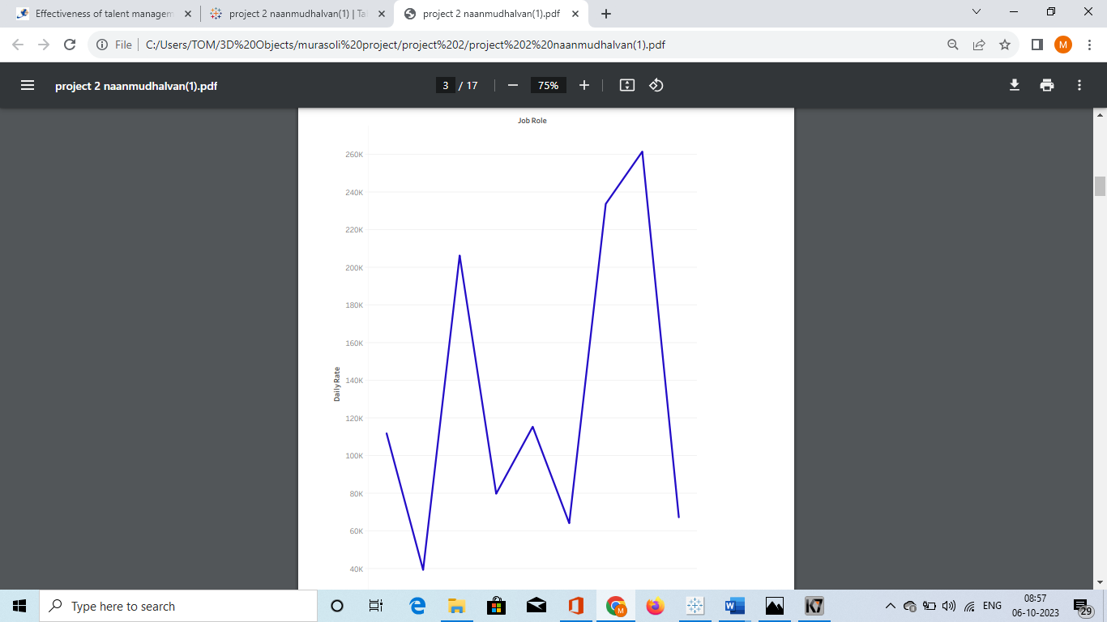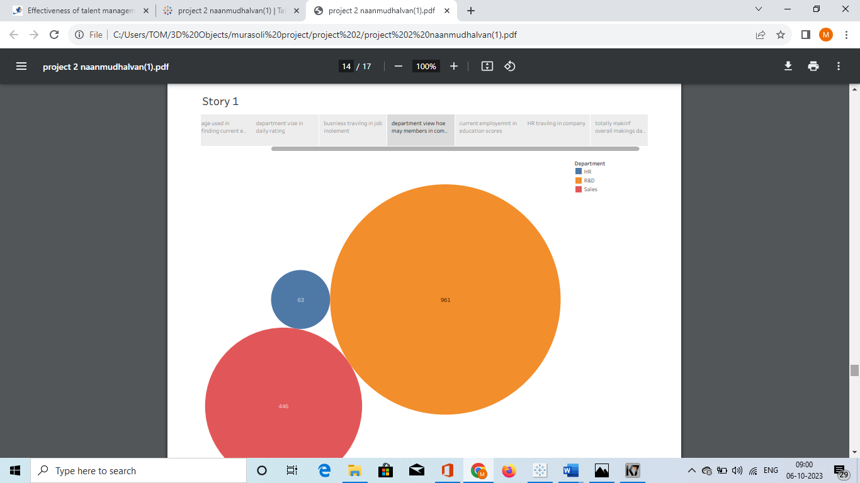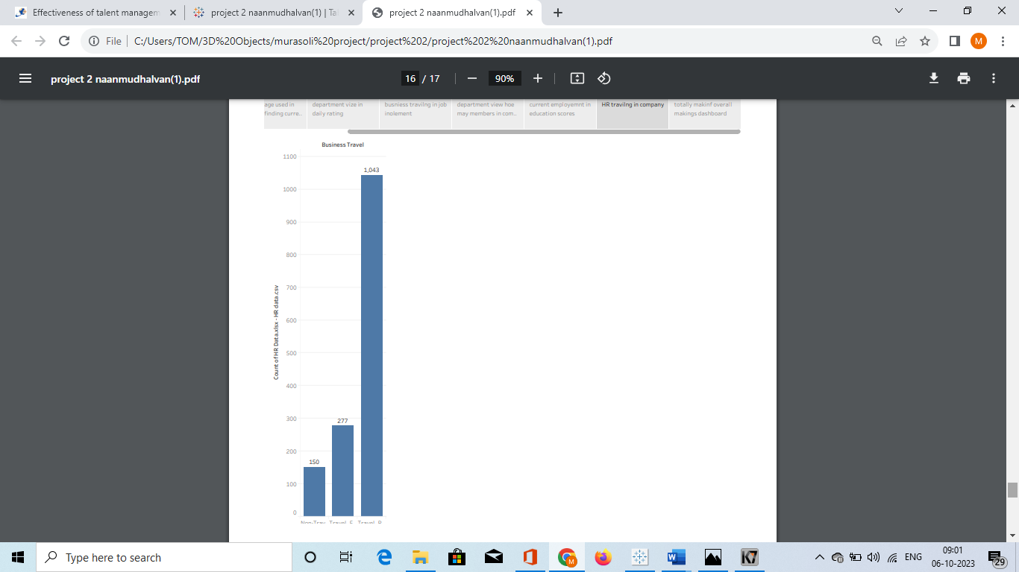

**Advantages:**

* **1. Recruitment, to ensure that the right people are**

**attracted to the organisation at the right time.**

* **Retention, to ensure the implementation and**

**development of practices that reward and support**

**employees.**

* **Employee development, to ensure continuous**

**informal and formal learning and development**

**processes.**

* **Leadership and “high-potential employee”**

**development, to ensure the availability of specific**

**development programs for current and future leaders**

**Disadvantages :**

* **high level of risk and short-term profit orientation is detrimental to the long-term interests of company**
* **Ability to be influenced by senior management and**
* **placement of important pieces of information for owners;**
* **Excessive requirements for the profitability of investment projects**

**APPLICATIONS:**

**• Access to ESS training enrollment and self-development.**

**• User-friendly interface.**

**• Connectivity with the client's existing information system (payroll accounting, ERP, attendance registration, document systems… gradual implementation.**

**• Parametric and customizability.**

**• Access to archived records and documents Employee & time managers self-manage employee mgt.**

**• The generation of HR metrics to support strategic decision making (Swaroop,2012).**

**• Transforming HR professionals from administrative paper handlers to strategic partners**

**• The automation of routine HR tasks and replacing “filing cabinets”**

**CONCLUSION :**

**The goal of this research was to find out what is the level and importance of financial literacy**

**for the successful management of family firms. Multiple case study method assisted by**

**semistructured questionnaire was employed as the main research tool. We have explored the**

**education of management of family firms and also the way how financial management is**

**organized.**

**FUTURE SCOPE :**

**The scope of talent management fall into five major categories: recruitment, performance**

**management, succession planning, training and development and retention. Each of the five**

**components plays a significant role in talent management, but are viewed as a complete set of**

**processes an organization must employ to successfully manage the talent .**

**APPENDIX :**

**Introduction**

[**https://www.adp.com/resources/articles-and-insights/articles/w/what-is-talent-management.aspx**](https://www.adp.com/resources/articles-and-insights/articles/w/what-is-talent-management.aspx)

**ADVANDAGES:**

[**https://blog.clearcompany.com/6-benefits-of-effective-human-resource-management**](https://blog.clearcompany.com/6-benefits-of-effective-human-resource-management)

**APPLICATION :**

[**https://www.spiceworks.com/hr/performance-management/articles/what-is-hris/#:~:text=A%20human%20resource%20information%20system%20comes%20with%20three%20major%20applications,the%20effective%20backing%20of%20data**](https://www.spiceworks.com/hr/performance-management/articles/what-is-hris/#:~:text=A%20human%20resource%20information%20system%20comes%20with%20three%20major%20applications,the%20effective%20backing%20of%20data)**.**

**CONCLUSION**

<http://www.acas.org.uk/index.aspx?articleid=1461>

**FUTURE SCOPE:**

[**https://www.whatishumanresource.com/scope-of-Human-Resource-Management**](https://www.whatishumanresource.com/scope-of-Human-Resource-Management)